Possibilities for high school education in agriculture
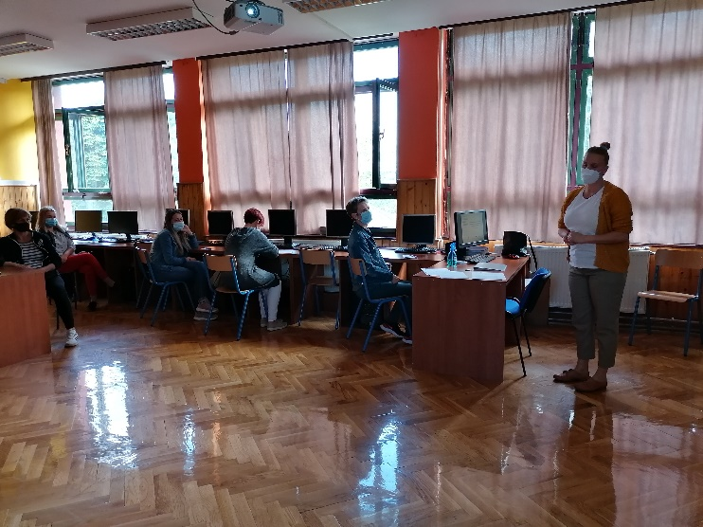
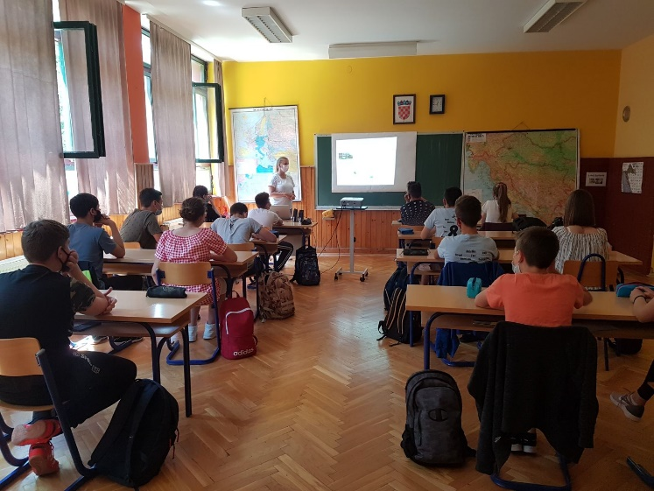

As a part of our project we have decided to cooperate with High school “Arboretum Opeka” from Marčan which takes part in another Erasmus + project. Their partners are High school Ludbreg and High school Bedekovčina. All of them educate students for agricultural professions.
Representatives of the High school “Arboretum Opeka” have presented their and their partners’ schools to our 8th grade students and their parents on the 31st of May 2021 in our school.
They pointed out the advantages of these professions:
- the EU is interested in modern specialised agricultural production
- eco-agriculture on small agricultural parcels with high market value
- self-employment
- introducing new/old agricultural crops
- educated agricultural enterpreneur

What does the EU demand?
- educated agricultural producer
- entrepreneur (organizing, IT and marketing skills, EU oriented, fluent in at least one foreign language)
- ready to implement the EU-market standards (know-how, skills, technologies and products)

After graduating from this high school students can continue their education at the Faculty of Agriculture or other similar faculties.
Since we live in a village where some people practice agriculture the students have shown a great interest because they were introduced to new possibilities for their future in farming.

Ivana Biluš, Sunčica Vuljak

